FAKE NEWS DETECTION USING NLP

|  |  |
| --- | --- |
| **Date** | **18-10-2023** |
| **Team Id** |  |
| **Project name** | **Fake News Detection using NLP** |

INTRODUCTION

Detecting fake news using Natural Language Processing (NLP) is an important application of machine learning and text analysis techniques. Fake news is a significant problem in the digital age, and NLP can be a valuable tool to identify and combat it. Here's an overview of the steps involved in fake news detection using NLP:

1. **Data Collection**: Gather a dataset of news articles with labels indicating whether they are real or fake. There are several publicly available datasets for this purpose, such as the Fake News Challenge dataset or fact-checking websites' data.

2. **Preprocessing**: Prepare the text data for analysis by performing various preprocessing steps like tokenization, stop-word removal, stemming/lemmatization, and lowercasing. These steps help in standardizing the text data and reducing noise.

3. **Feature Extraction**: Transform the text data into numerical features that machine learning models can work with. Common techniques include TF-IDF (Term Frequency-Inverse Document Frequency) and word embeddings like Word2Vec, GloVe, or BERT embeddings. These embeddings capture the semantic meaning of words and phrases.

4. **Feature Engineering**: Create additional features that might be informative for fake news detection. For example, you could include features like article length, the publication source, the publication date, or the number of hyperlinks.

5. **Model Selection**: Choose an appropriate machine learning model for classification. Common choices include:

- **Multinomial Naive Bayes**: A simple and efficient model for text classification.

- **Logistic Regression**: Often used for binary classification tasks.

- **Random Forest**: An ensemble model that can capture complex patterns.

- **Support Vector Machine (SVM)**: Effective for high-dimensional data.

- **Deep Learning Models**: Recurrent Neural Networks (RNNs) and Convolutional Neural Networks (CNNs) can also be used for NLP tasks.

6. **Training and Testing**: Split the dataset into training and testing sets. Train the selected model on the training data and evaluate its performance on the testing data using metrics like accuracy, precision, recall, F1-score, and ROC AUC.

7. **Tune Hyperparameters**: Optimize the model's hyperparameters to achieve the best performance. Techniques like grid search or random search can help with this.

8. **Ensemble Methods**: Combine multiple models to improve accuracy and robustness. Ensemble methods like stacking, bagging, or boosting can be useful.

9. **Real-Time Monitoring**: Implement a real-time monitoring system that can analyze news articles as they are published. This might require continuous data collection and processing.

10. **Post-processing**: Implement post-processing steps like thresholding to make the final prediction (e.g., deciding whether an article is real or fake) based on the model's output probabilities.

11. **User Interface**: If this system is intended for public use, consider developing a user-friendly interface where users can submit articles for analysis and receive results.

12. **Regular Updates**: Fake news detection models should be regularly updated to adapt to new tactics used by malicious actors to spread misinformation.

13. **Ethical Considerations**: Ensure that the fake news detection system is designed with ethical considerations in mind, avoiding biases and privacy violations.

Remember that fake news detection is a challenging and ongoing problem, and the effectiveness of NLP models in detecting fake news can vary. Continuous research and development are essential to stay ahead of those who create and spread false information.

df=pd.read_csv('fake-news/train.csv')

df.head()

**output:-**

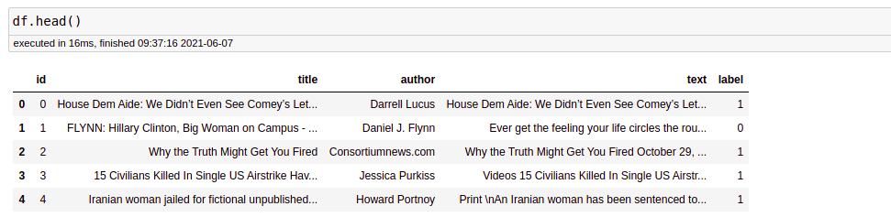

Before proceeding, we need to check whether a null value is present in our dataset or not.

df.isnull().sum()

There is no null value in this dataset. But if you have null values present in your dataset then you can fill it. In the code given below, I will tell you how you can replace the null values.

df = df.fillna(' ')

CONCLUSION

The passive-aggressive classifier performed the best here and gave an accuracy of 93.12%.

We can print a confusion matrix to gain insight into the number of false and true negatives and positives

Fake news detection techniques can be divided into those based on style and those based on content, or fact-checking. Too often it is assumed that bad style (bad spelling, bad punctuation, limited vocabulary, using terms of abuse, ungrammaticality, etc.) is a safe indicator of fake news.